1. 
2. 
3. 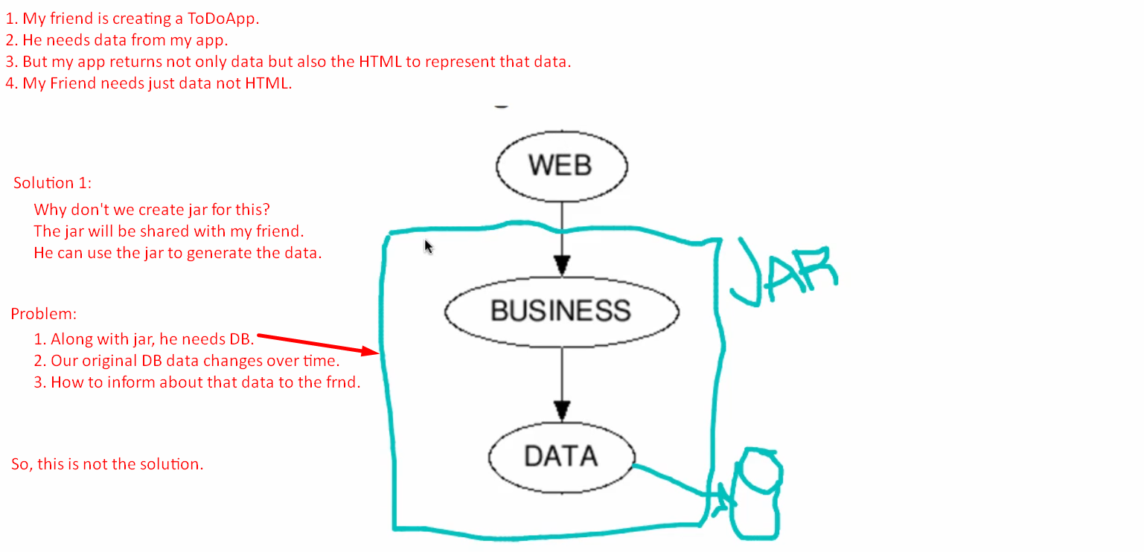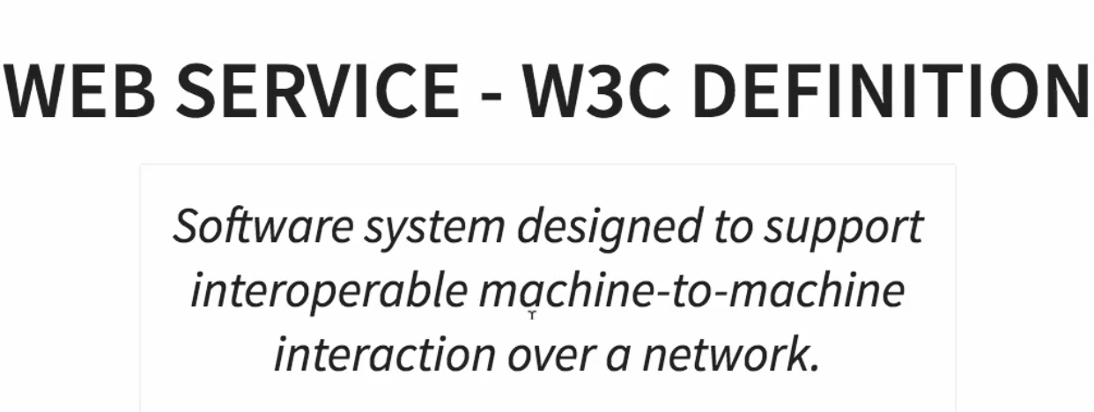
4. **There are 3 key terms**:
   1. Interoperable.
   2. Machine-to-machine
   3. Over network.
5. 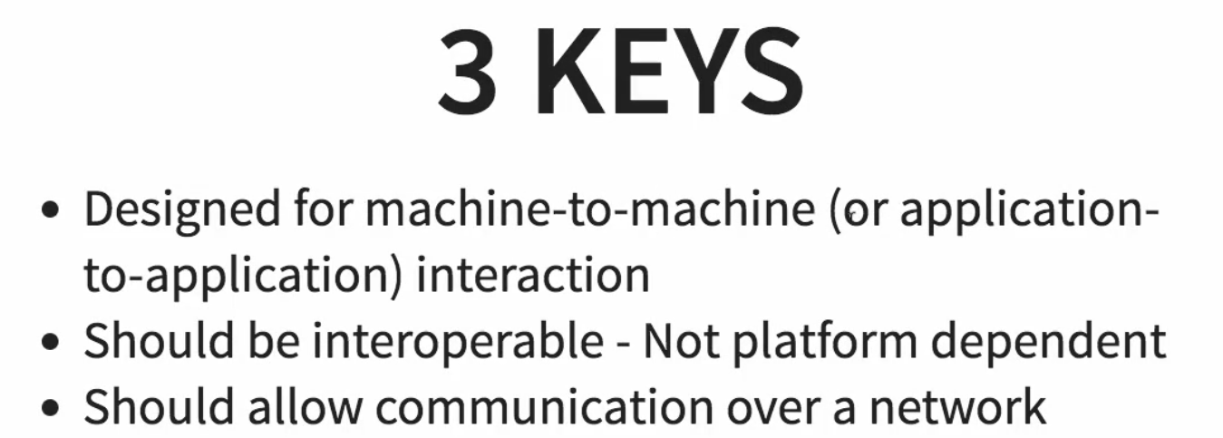
6. 